EXP 3

P Sharweshvar

240701491
MANISHA M

REPORTS IN ZOHO CREATOR

AIM
To create different types of reports in Zoho Creator for viewing, organizing, and analyzing the student information stored in the Student Management System forms.

PROCEDURE
- Open the Student Management System application in Zoho Creator.
- Create reports for the Student Profile, Academic, Guardian Contact, and Course Enrollment forms.
- Create suitable report types such as:
  - List Report – to display student records in tabular format.
  - Kanban Report – to categorize students based on suitable fields such as Department or Semester.
  - Calendar Report – to display course enrollment dates.
  - Pivot Table Report – to analyze students based on Department, Semester, or Course.
  - Pivot Chart Report – to graphically represent academic or enrollment data.
- Configure the required fields and filters for each report.
- Add sample records and verify that the reports display the correct information.
- Preview all reports and check their functionality.

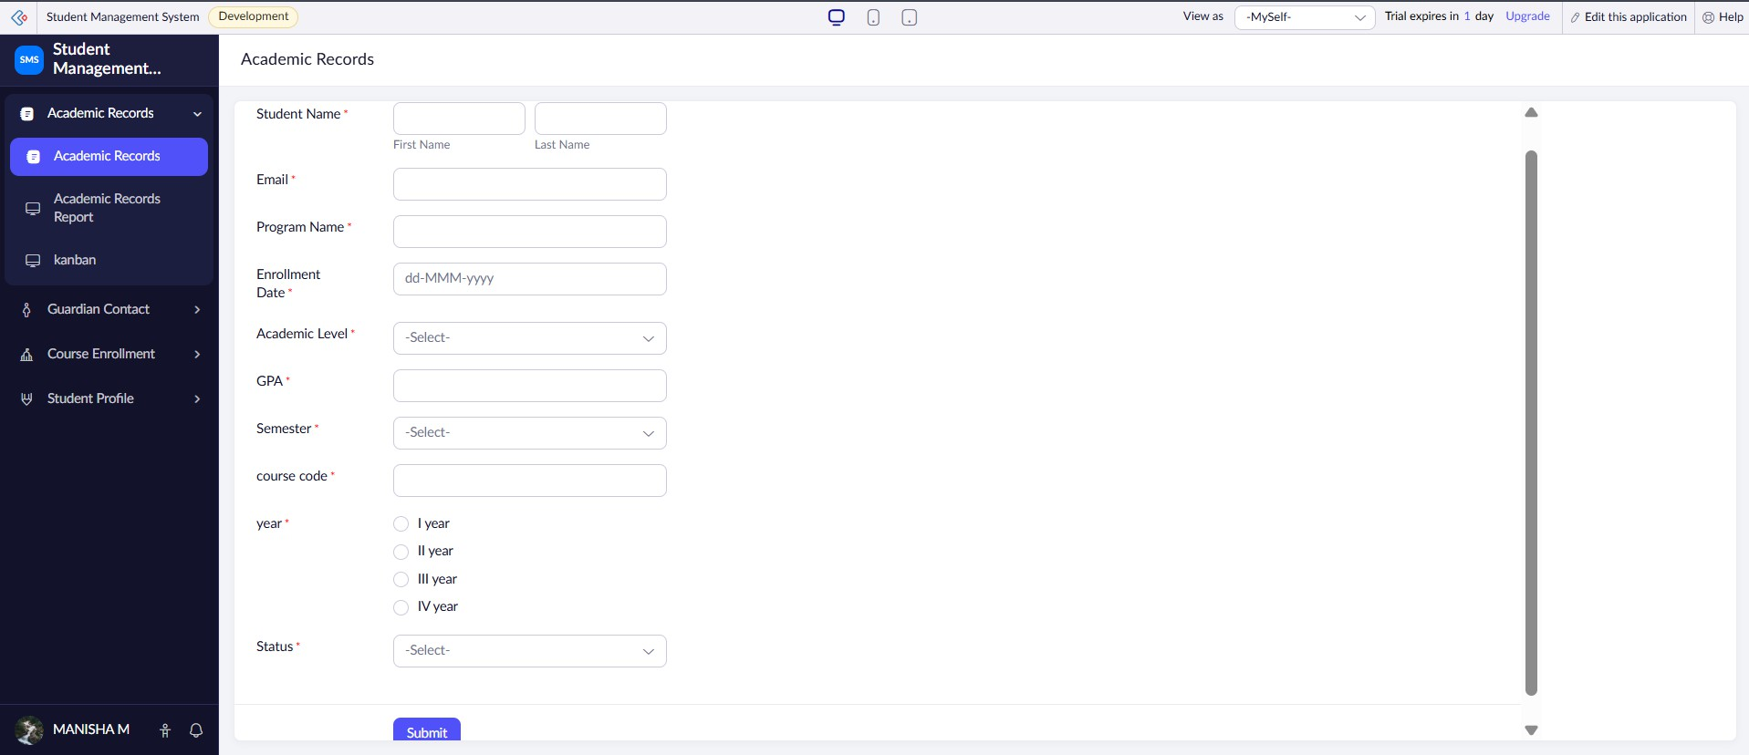
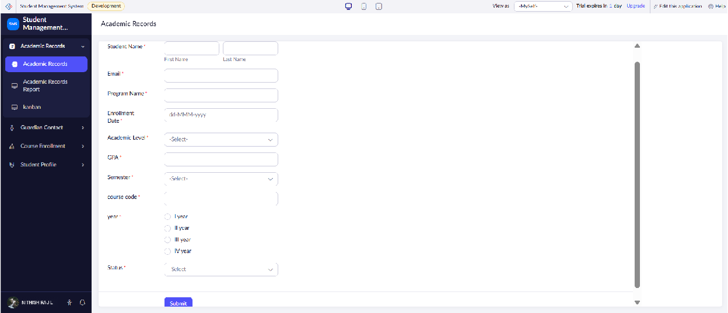
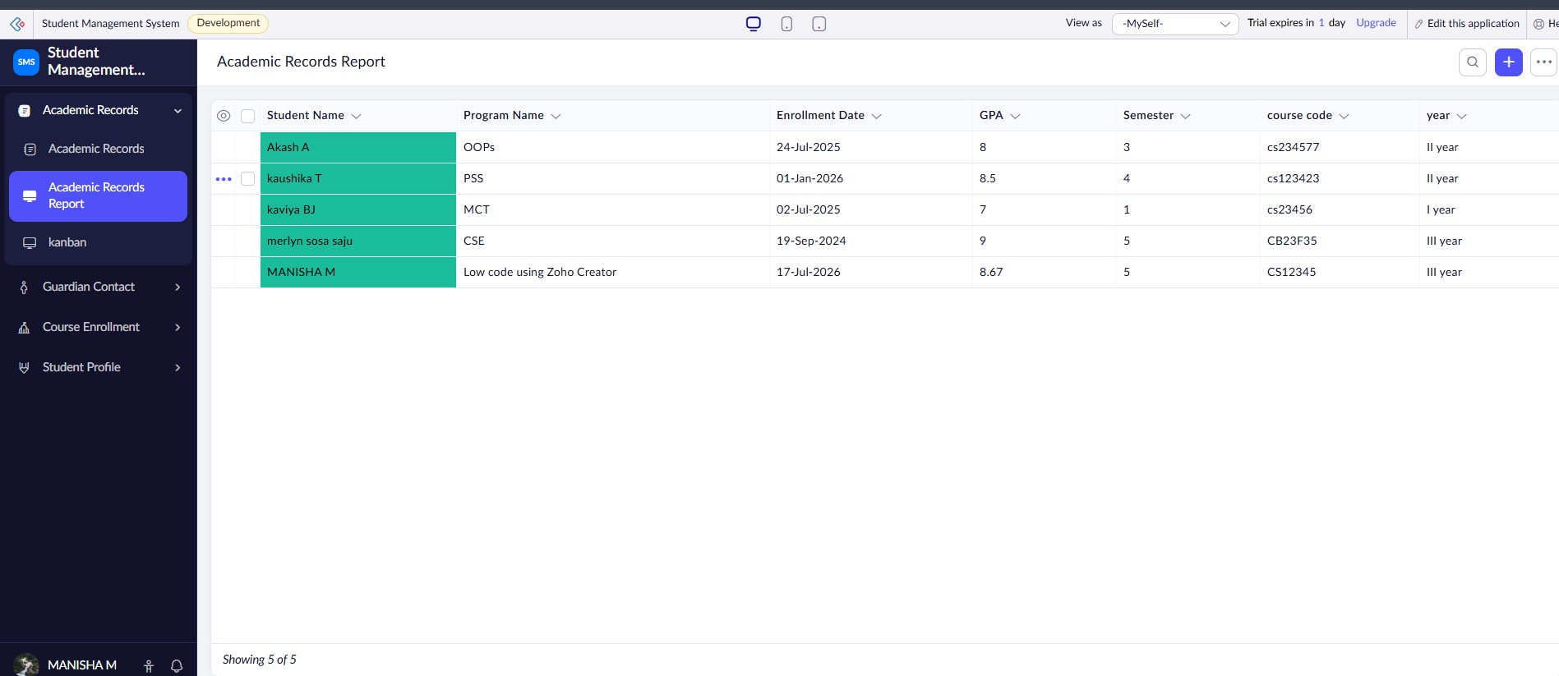
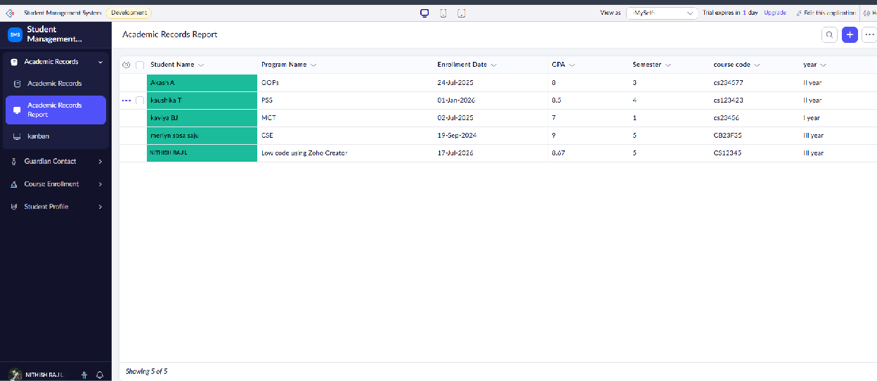
OUTPUT

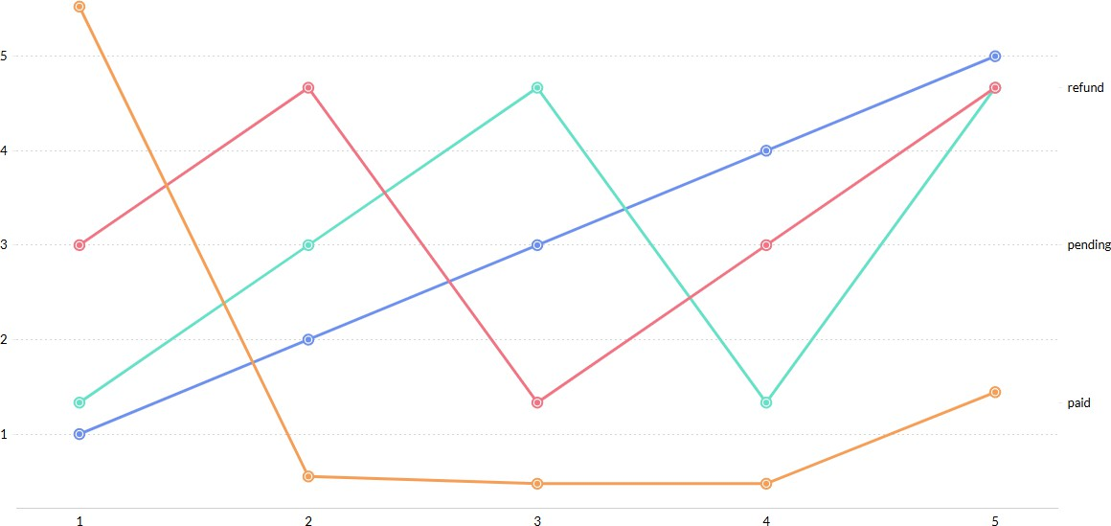
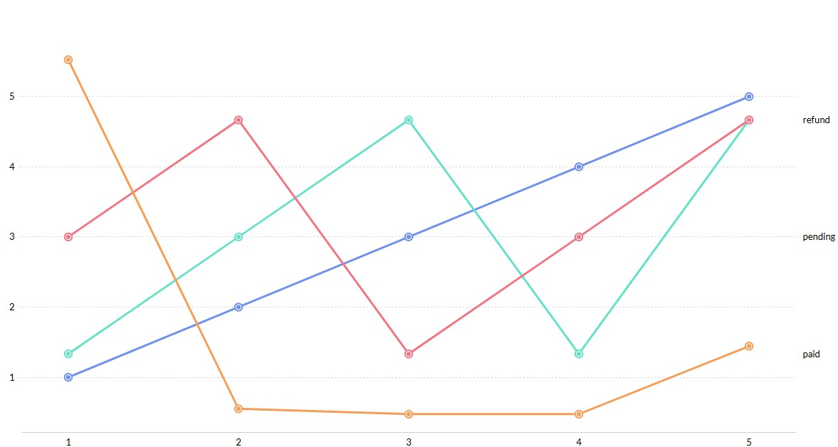
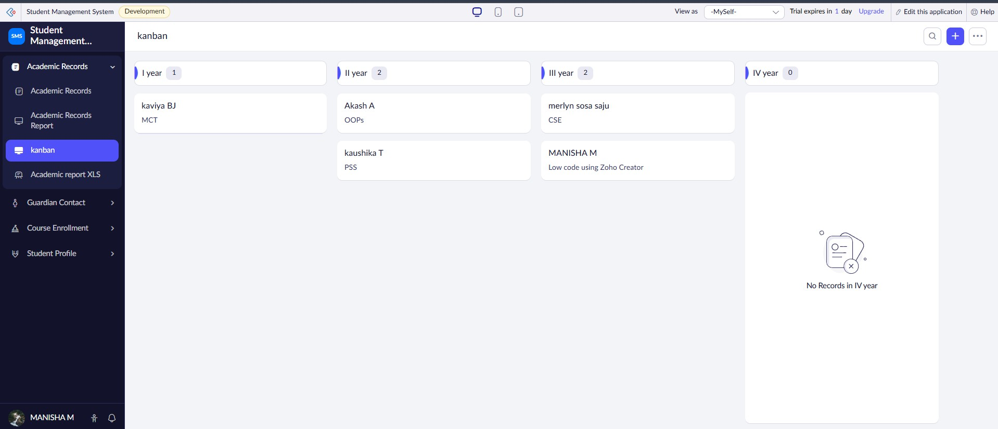
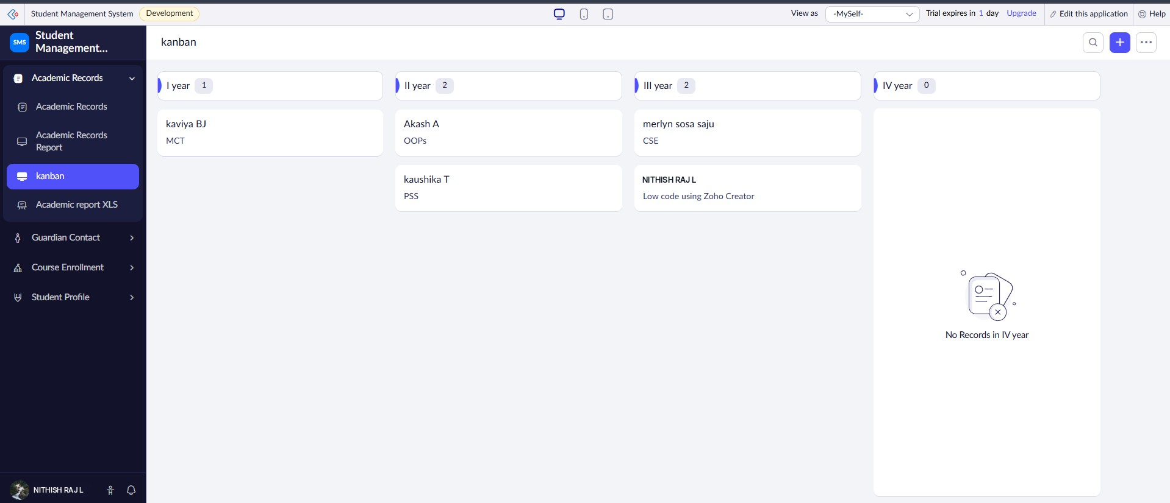

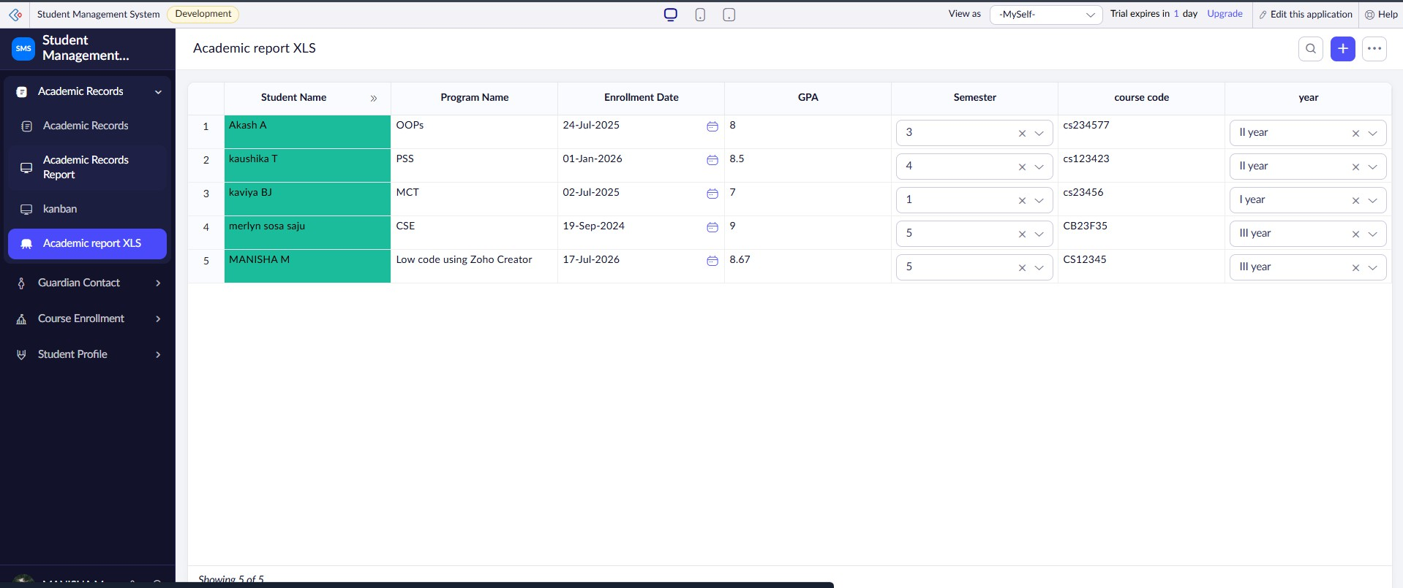
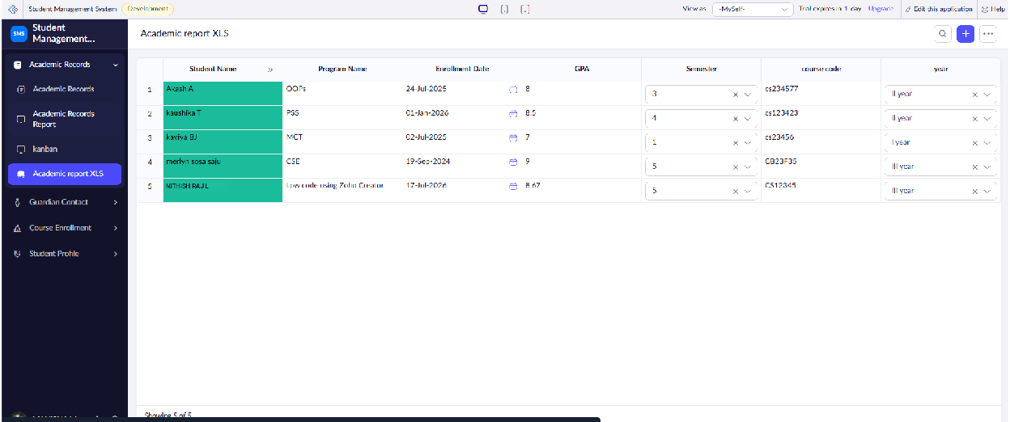
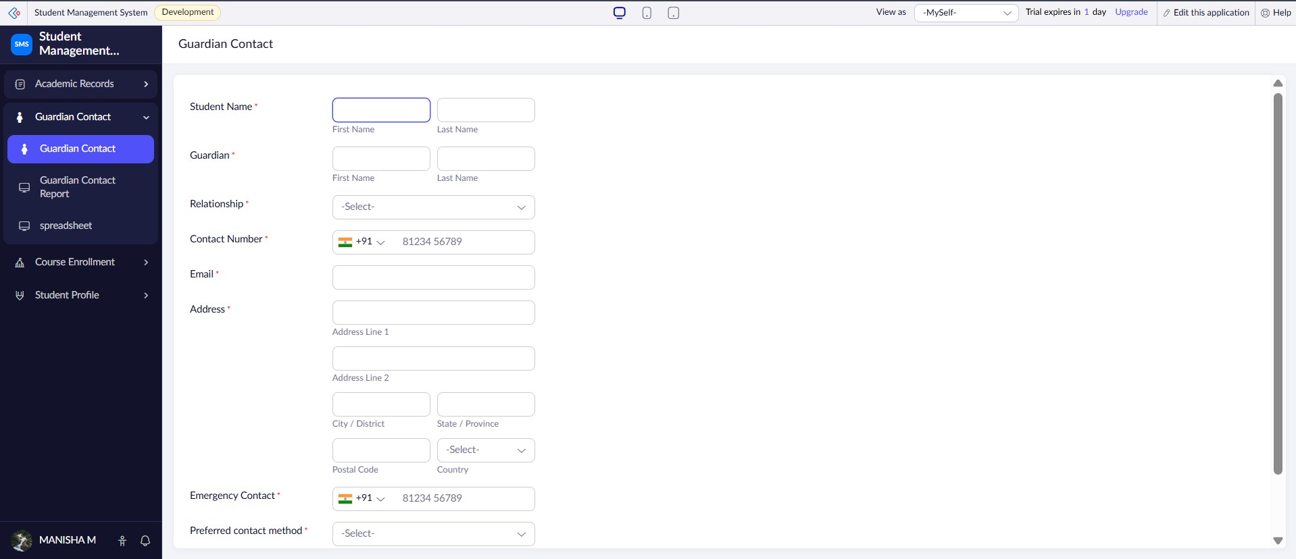
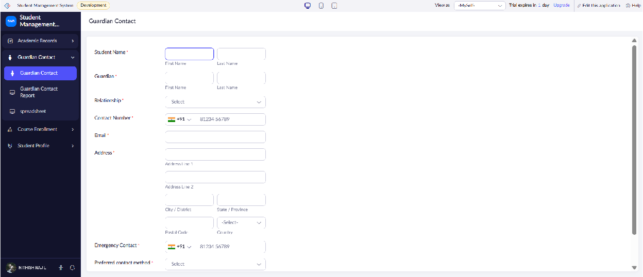
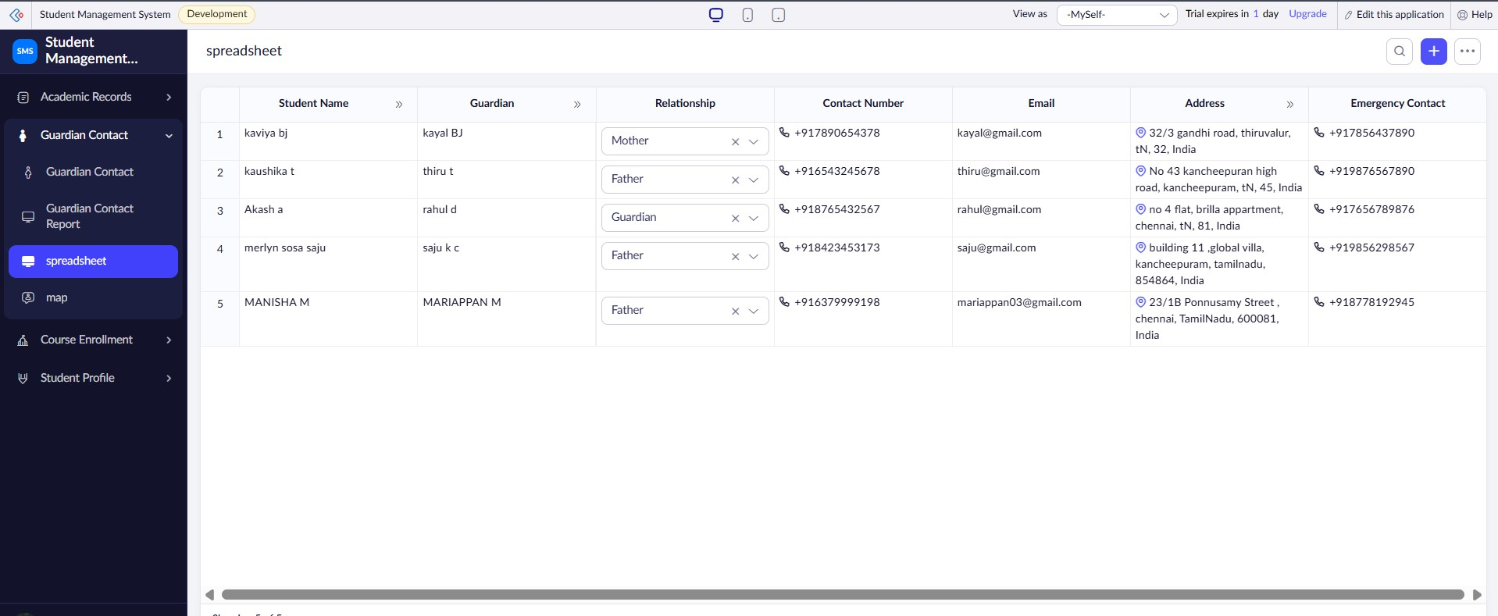
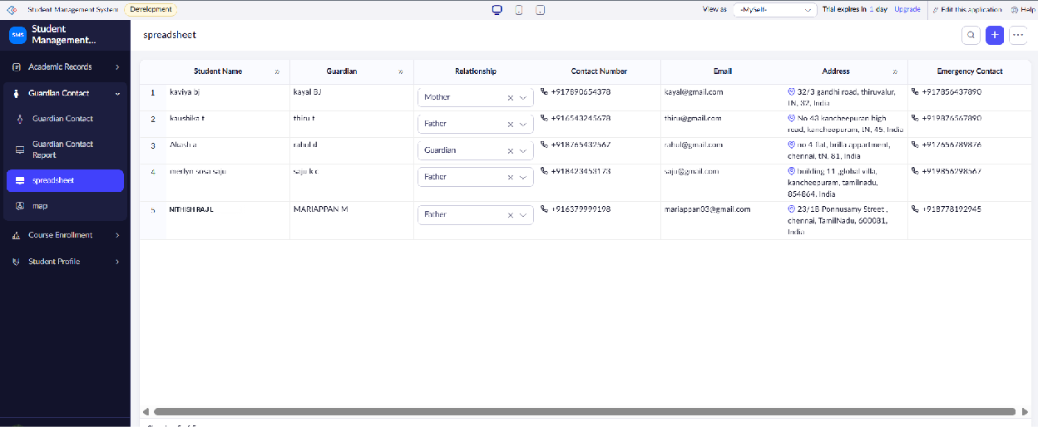

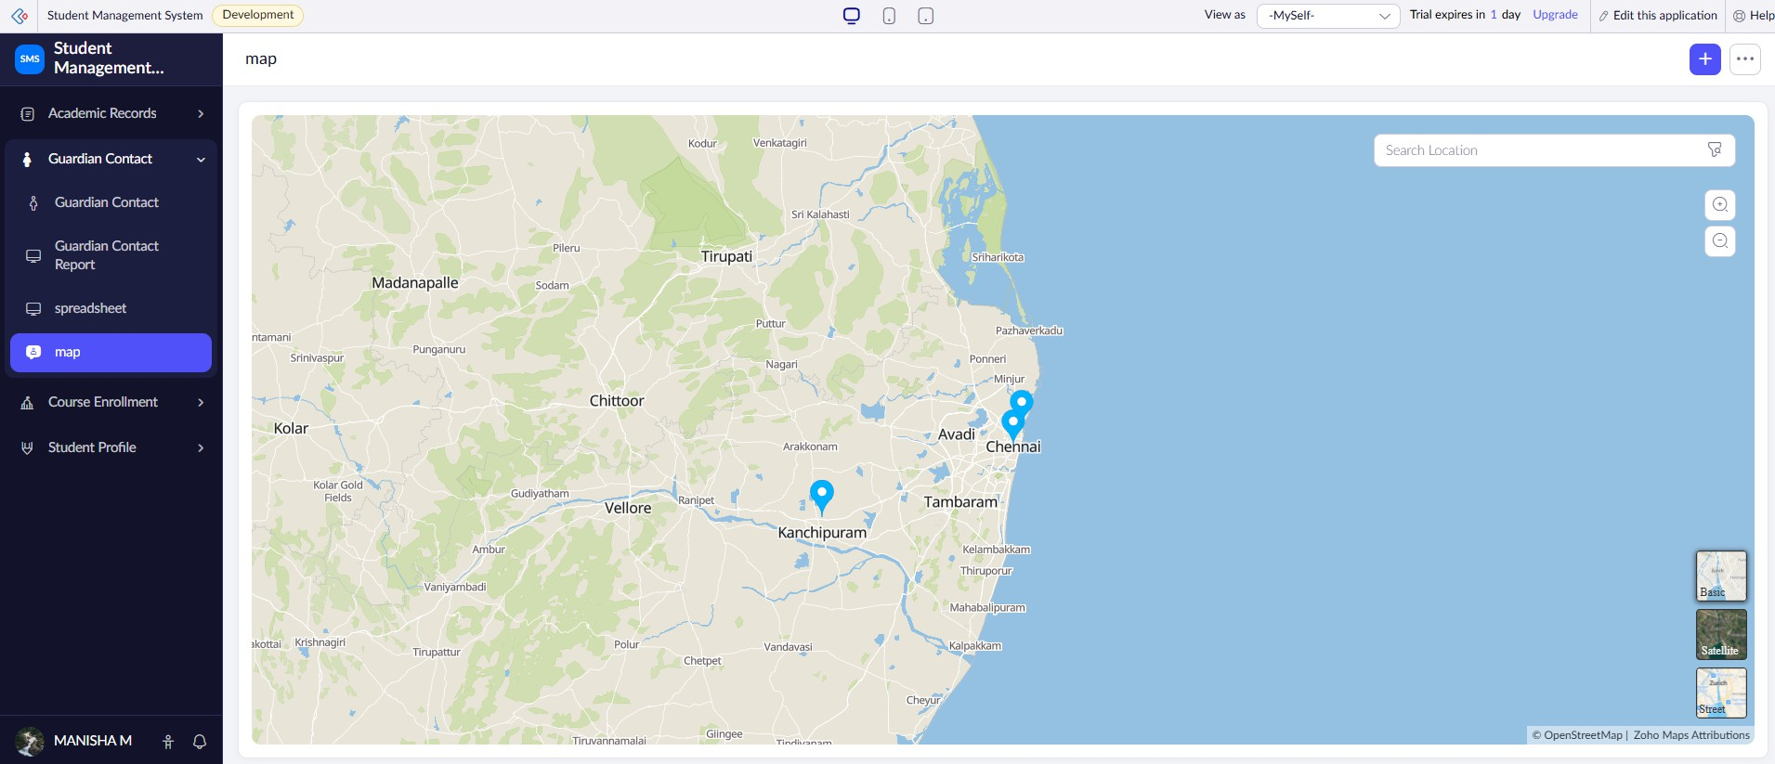
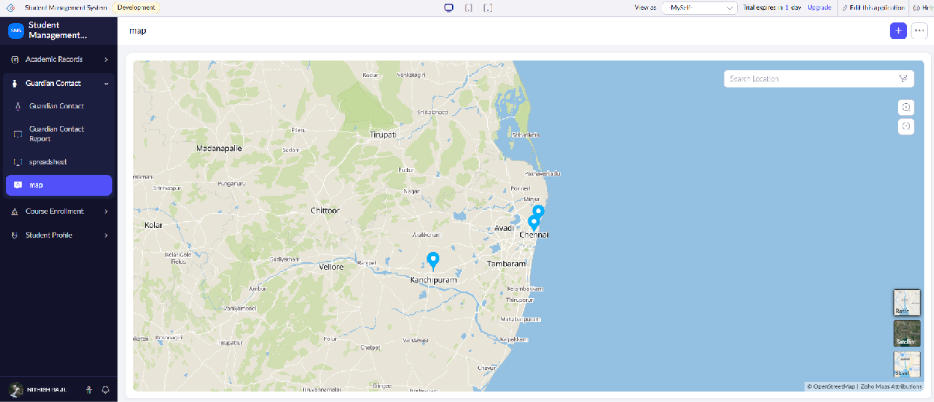
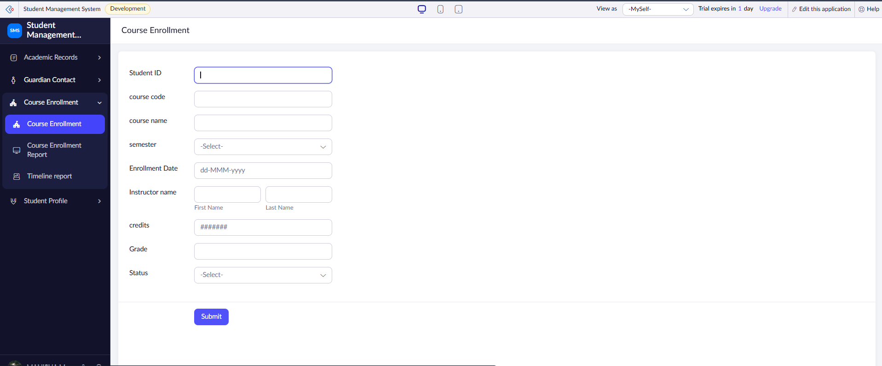
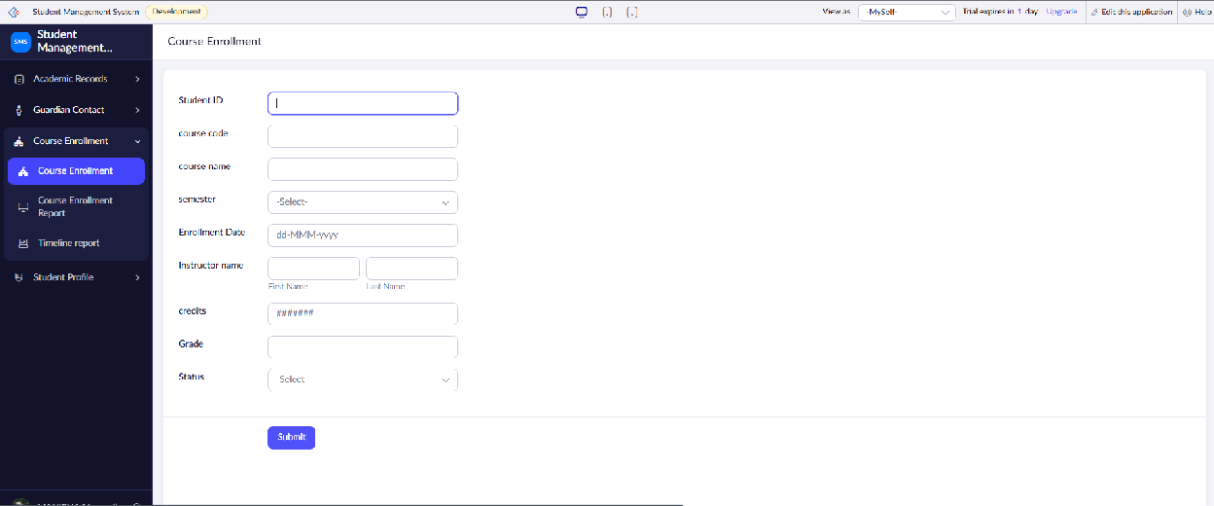
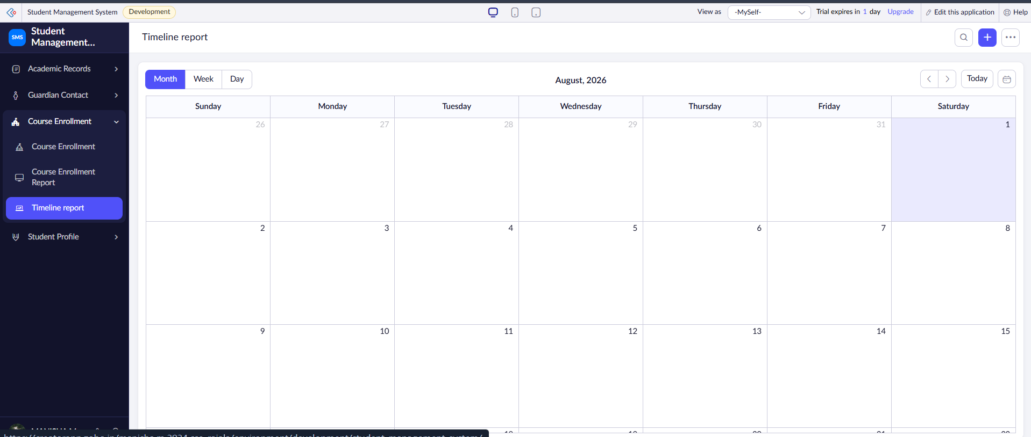
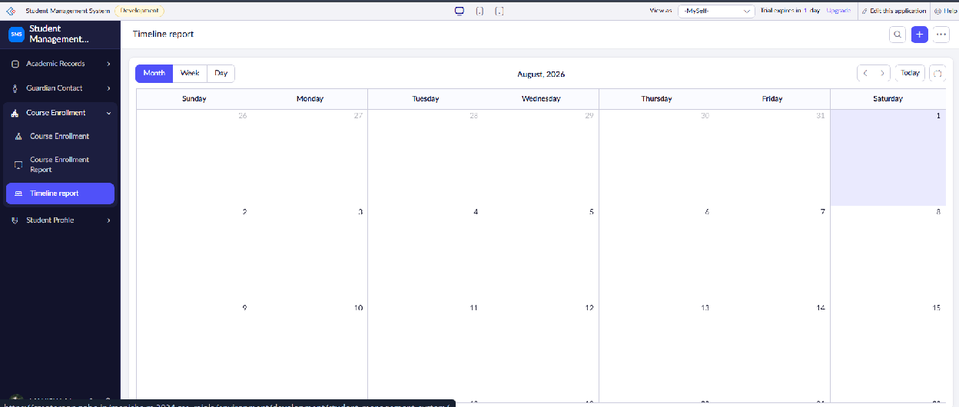

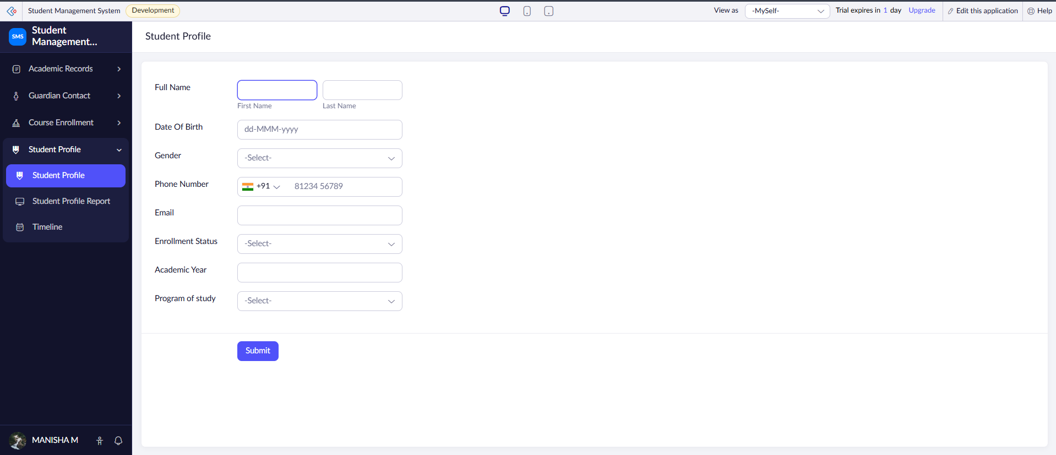
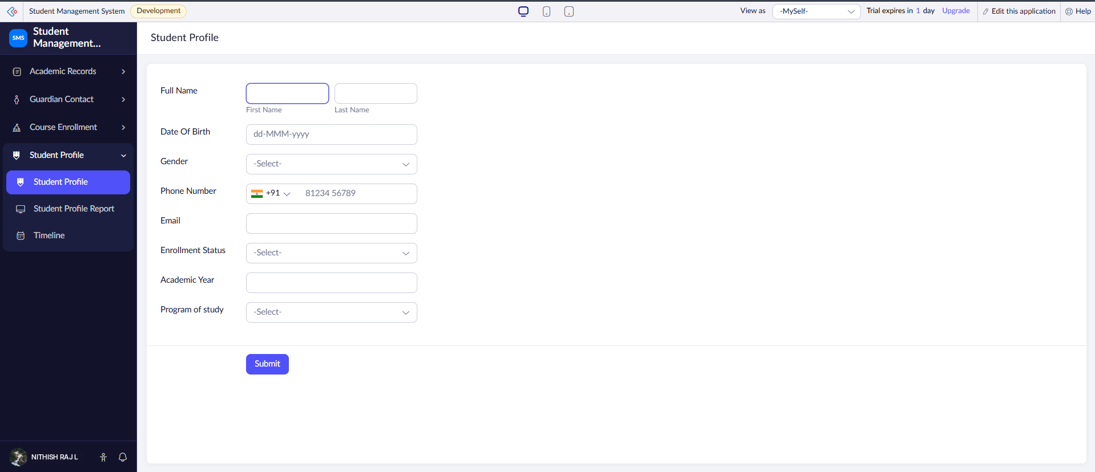
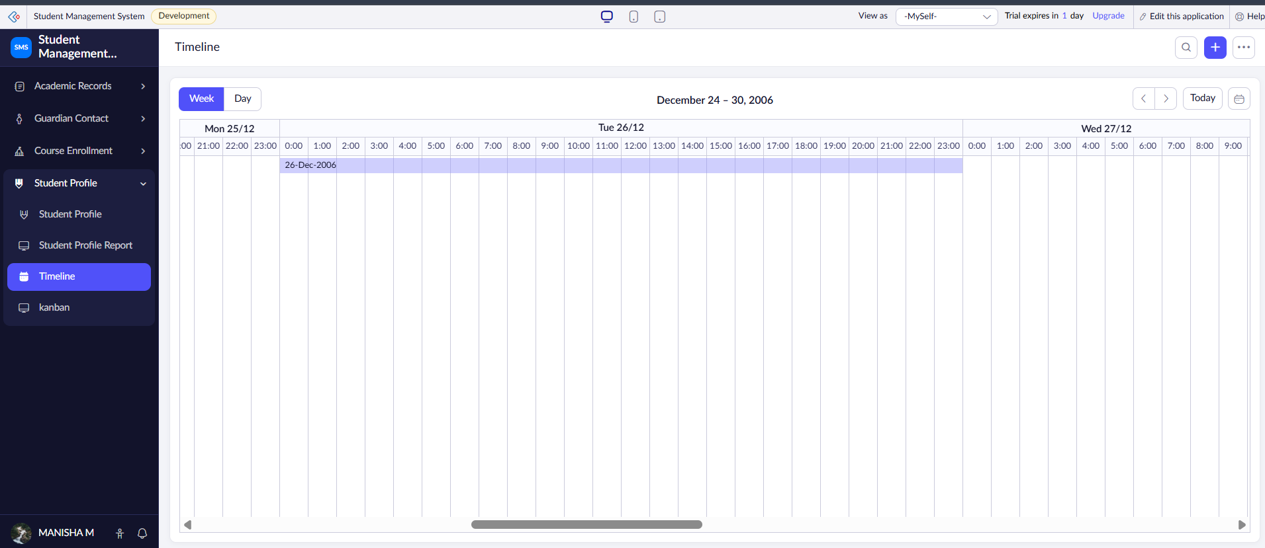
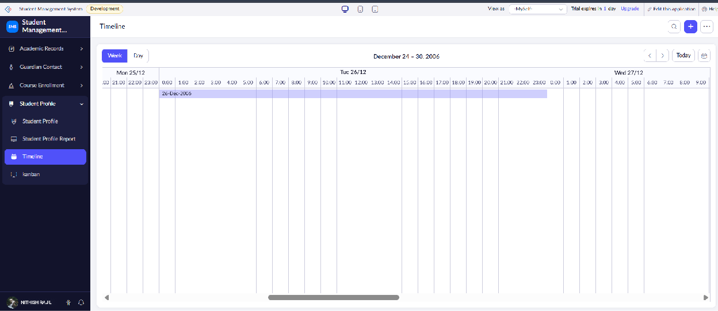

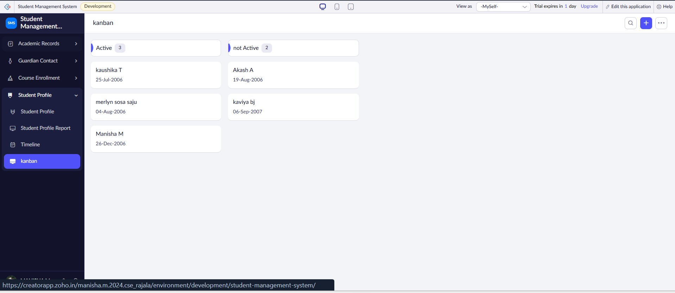
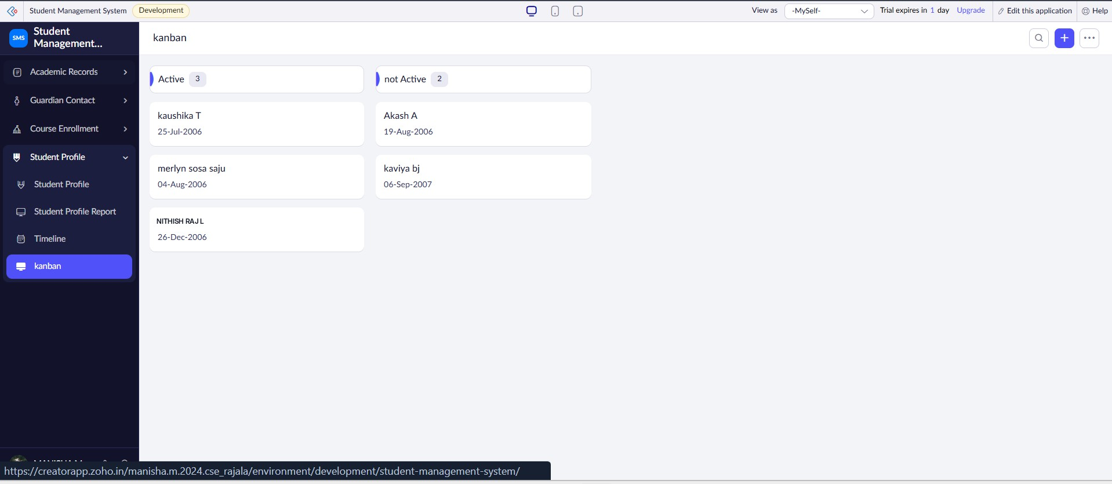
RESULT:
Thus, different reports were successfully created from the Student Profile, Academic, Guardian Contact, and Course Enrollment forms in Zoho Creator for effective viewing and analysis of student information.

